Date:................................ Name:....................................
Weekly Record

Do it yourself
Monday to Friday Mood monitoring data. R stands for Red
Y stands for Yellow G stands for Green

R Y G

Monday

Tuesday

Wednesday

Thursday

Friday
7am - 10am 11am - 2pm 3pm - 6pm 7pm - 10pm

7am - 10am 11am - 2pm 3pm - 6pm 7pm - 10pm

7am - 10am 11am - 2pm 3pm - 6pm 7pm - 10pm

7am - 10am 11am - 2pm 3pm - 6pm 7pm - 10pm

7am - 10am 11am - 2pm 3pm - 6pm 7pm - 10pm

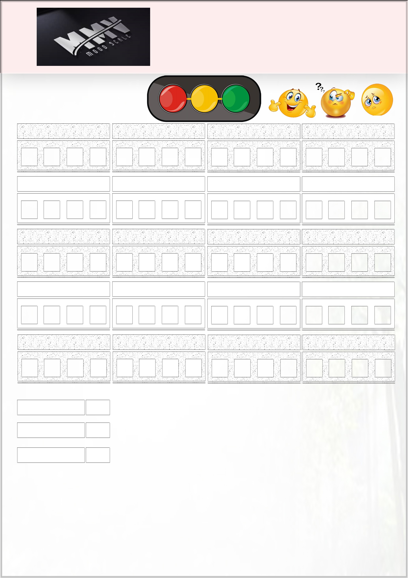

Total Green: Total Yellow:
Total Red:

MMV Moodscale has some simple tips to help you take control of your thoughts.

If Red is more than the total of Green plus Yellow at the end of the week,
kindly speak to a family member, friend, your Manager, Head of Department or speak to your GP immediately.

